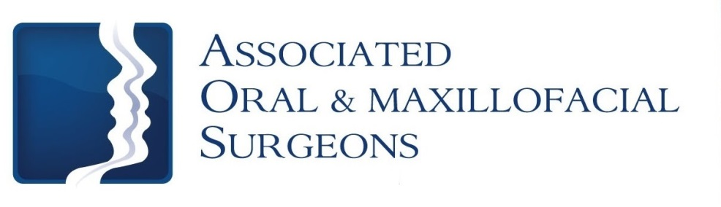
Robert J. Busch, D.M.D., M.D. Larry D. Otte, D.M.D.
James W. Pledger, II, D.D.S. Nathan D. Schroeder, D.M.D., M.S.

Post–op Care for Bone Grafting Procedures

- Do your best to not disturb or agitate area of bone graft in any way. Leave area alone in order to assure an adequate healing process.

- Continue normal hygiene – brush your teeth twice a day. Do not brush the graft area for 3 weeks or until your next visit to our office.

- A soft food diet is recommended for 3 weeks. Avoid chewing any foods on the side of the surgical site.

- All medications should be taken AS PRESCRIBED and until gone. Please note, do not swish with prescribed Peridex rinse. Simply hold solution in mouth at the surgical site for 30 seconds and gently spit rinse from mouth.

- Return to our office for all post-operative appointments.

Like, Share, and Tell your Friends
Follow us at www.facebook/aosillinoiscom & www.twitter/aosillinois.com
or visit us at www.aosillinois.com

2807 North Knoxville Avenue - Peoria, Illinois 61604 - Phone 309-682-1213 - After Hours 309.322.2313

