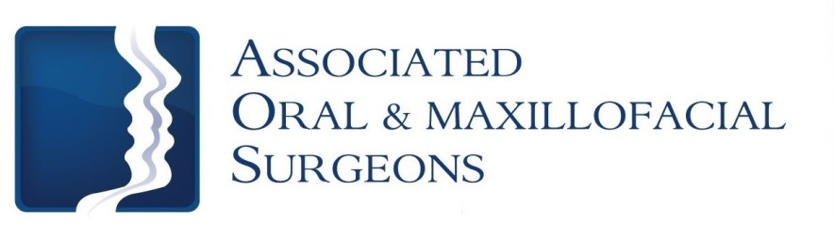
Robert J. Busch, D.M.D., M.D. Larry D. Otte, D.M.D.
James W. Pledger, II, D.D.S. Nathan D. Schroeder, D.M.D., M.S.
Post-Op Care for Hospital Surgery
Activity
For the first 48 hours you should rest and relax with no physical activity. After 48 hours, you may resume activity as tolerated.

Fainting Precaution
If you suddenly sit or stand from a lying position you may become dizzy, especially if you have not eaten or have had limited fluids. Therefore, make sure to sit upright for one full minute before standing immediately following surgery.

Pain
Unfortunately, most oral surgery is accompanied by some degree of discomfort. If you do not have an allergy to non-steroidal anti-inflammatory medications like Ibuprofen (Motrin, Advil), we recommend you alternate Ibuprofen and the narcotic medication. First, take narcotic medication then a couple hours later take 400mg (2 tablets / 200mg each) of Ibuprofen. Alternate these medications as prescribed. While taking a narcotic pain medication you may not drive or operate mechanical machinery. The prescribed pain medication will make you drowsy. Once you feel like you can stop the narcotic, use Ibuprofen or Tylenol. All medication should not exceed the recommended dosage.

Bleeding
Bleeding after surgery may continue for several hours. The best way to stop bleeding is to fold 2 pieces of damp gauze over the extraction site and gently bite for 30-60 minutes making sure pressure is being applied to the extraction site. Rest quietly with your head elevated. If bleeding continues, use gauze for an additional 30 minutes. Bleeding should always be evaluated by looking directly at the surgical site. Pink or blood-tinged saliva may be seen for 2-3 days following the surgery and does not indicate a problem.

( over )

Swelling
Swelling is the body’s normal reaction to surgery and healing. The swelling will not become apparent until the day following surgery and will not reach its peak for 2-3 days. After this time, the swelling should decrease but may persist for 7-10 days.

Swelling may be minimized by the immediate use of ice packs. Apply the ice packs to the outside of the face 20 minutes on and then 20 minutes off while awake for the first 24 hours. After 48 hours, begin use of a warm, moist compress to the cheek.
Diet
After general anesthesia or I.V. sedation, start with liquids. While numb, patients should avoid hot liquids or foods. Patients may have applesauce, pudding, or jello. Once the numbness wears off, patients can progress to solid foods. Be sure to chew away from the surgical sites. Patients should avoid foods like nuts, sunflower seeds, popcorn, chips, or foods that can get lodged in the surgical areas.

Add Bland Soft Foods When Numbness is Gone
Mashed Potatoes
Pasta
Eggs
Pancakes
Creamed Cereals
Soups (be careful – not too hot)

AVOID carbonated beverages and hot liquids for 48 hours

Increase Diet as Tolerated Unless Given Instructions to Stay on Soft Foods

Like, Share, and Tell your Friends
Follow us at www.facebook/aosillinois.com & www.twitter/aosillinois.com
or visit us at www.aosillinois.com

