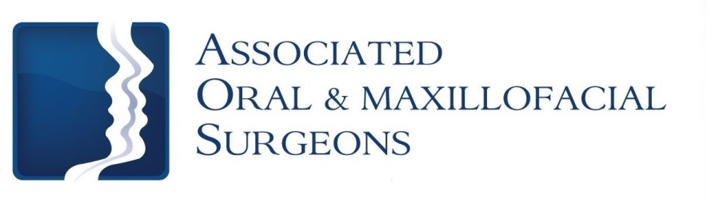
Robert J. Busch, D.M.D., M.D. Larry D. Otte, D.M.D.
James W. Pledger, II, D.D.S. Nathan D. Schroeder, D.M.D., M.S.

Post-Operative
Sinus Involvement Instructions

- Bite on moistened gauze pack that has been placed over the wound for at least one hour

- Do NOT blow your nose for 21 days. Do NOT stifle sneezes or sneeze through your nose. If the urge to sneeze arises, sneeze with your mouth open

- Avoid smoking for 21 days
4. No swimming or heavy exercise for 3 weeks
5. Stick to a soft food diet for your own comfort - chew on the opposite side
6. Continue normal hygiene – be sensitive to the wound area
7. Return to our office for all scheduled post – operative appointments
8. Take ALL prescriptions as ordered by your Doctor

