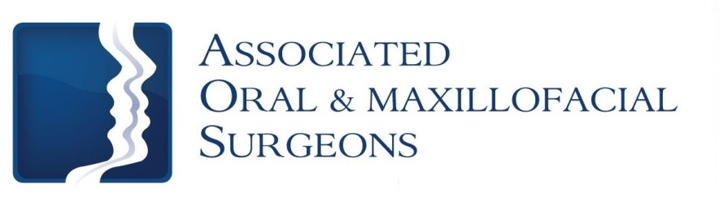

Robert J. Busch, D.M.D., M.D. Larry D. Otte, D.M.D.
James W. Pledger, II, D.D.S. Nathan D. Schroeder, D.M.D., M.S.

Post-op Care for Tooth Extraction

Bleeding
Bleeding after surgery may continue for several hours. The best way to stop bleeding is to fold 2 pieces of damp gauze over the extraction site and gently bite for 30-60 minutes making sure pressure is being applied to the extraction site. Rest quietly with your head elevated. If bleeding continues, use gauze for an additional 30 minutes. Bleeding should always be evaluated by looking directly at the surgical site. Pink or blood-tinged saliva may be seen for 2-3 days following the surgery and does not indicate a problem.

Swelling
Swelling is the body’s normal reaction to surgery and healing. The swelling will not become apparent until the day following surgery and will not reach its peak for 2-3 days. After this time, the swelling should decrease but may persist for 7-10 days.

Swelling may be minimized by the immediate use of ice packs. Apply the ice packs to the outside of the face 20 minutes on and then 20 minutes off while awake for the first 24 hours. After 48 hours, begin use of a warm, moist compress to the cheek.

Pain
Unfortunately, most oral surgery is accompanied by some degree of discomfort. If you do not have an allergy to non-steroidal anti-inflammatory medications like Ibuprofen (Motrin, Advil) we recommend taking this prior to the local anesthetic wearing off. More severe pain may require a narcotic pain medication. Alternate Ibuprofen and the narcotic medication. First, take narcotic medication then a couple of hours later take 400 mg (2 tablets / 200mg) of Ibuprofen. (Ibuprofen dosage may vary for younger patients. Please reference bottle for appropriate dosage based on height and weight.) Alternate these medications as prescribed. While taking a narcotic pain medication you may not drive or operate mechanical machinery. The prescribed pain medication will make you drowsy. Once you feel like you can stop the narcotic, use Ibuprofen or Tylenol. All medications should not exceed the recommended dosage.

*NOTE: If you are taking Plavix or Coumadin, do NOT take Ibuprofen or Aspirin products.

Discomfort should subside daily. If not, please call our office.

Dry Sockets
If a dry socket occurs (loss of blood clot from socket) there is constant pain that may radiate to other areas including ear, jaw, and teeth. Symptoms of a dry socket do not typically occur until the 5th to 7th day after the procedure. If you do not have improvement during the first few days following the procedure, call the office. A medicated dressing may be placed or a medicated syringe may be given if the medications taken by mouth do not resolve the discomfort.

To help prevent a dry socket avoid vigorous rinsing, sucking on the wound, spitting, using a straw, smoking and exercising for 2-3 days after procedure. You may gently rinse your mouth with a dilute mouth rinse of your choice after one day.
(over)

Diet
After General anesthetic or I.V. sedation, start with liquids. While numb, patients should avoid hot liquids or foods. Patients may have applesauce, pudding or jello. Once numbness wears off patients can progress to solid foods, chewing away from the surgical sites. Patients should avoid foods like nuts, sunflower seeds, popcorn, etc., which may get lodged in the socket areas.

Fainting precaution: If you suddenly sit or stand from a lying position you may become dizzy, especially if you have not eaten or have had limited fluids. Therefore, immediately following surgery, if you are lying down, make sure to sit for at least one full minute before standing.

Oral Hygiene
The best way to prevent infection and ensure healing is to keep your mouth clean. Clean your mouth thoroughly after each meal beginning the day after surgery. Use a soft bristle toothbrush and toothpaste after meals and at bedtime. Should bleeding resume after brushing, repeat the use of gauze as described above. Do not rinse your mouth the day of surgery.

Activity
For the first 24 hours you should rest and relax with no physical activity. After 24 hours, you may resume activity as tolerated. You may return to work/school as long as you are not taking the prescribed pain medication.

Healing
Bad breath is common and will disappear as healing occurs. Two to three days following surgery, white, possible hard tissue may be seen in the surgical site. This signifies normal, healing tissue. Complete healing of the extraction site may take 6-8 weeks.

Sutures/Stitches
Sutures will resorb or fall out on their own. It is normal for a suture to come out on the day of surgery. If bleeding occurs because the sutures have fallen out, bite on gauze to apply pressure as described on the first page.

Antibiotics
If an antibiotic is prescribed, take the tablets or liquid as directed. Take the entire prescription until gone. Antibiotics can be given to help prevent infection. Make sure to call the office if a rash or other unfavorable reaction occurs.

Foods to Drink and Eat While Numb – AVOID carbonated beverages and hot liquids for 48 hours
Drink: Eat:
Water Applesauce
Juice Jell-O
Ice Chips Pudding
Like, Share, and Tell your Friends
Follow us at www.facebook/aosillinois.com & www.twitter/aosillinois.com
or visit us at www.aosillinois.com

Popsicles Yogurt
Milkshake (no straw)

Add Soft Foods When Numbness is Gone

Mashed Potatoes
Pasta
Eggs
Pancakes
Creamed Cereals
Soups (be careful-not too hot)
Increase Diet as Tolerated

